**Application of Shape Memory Alloys in Brain-Computer Interfaces for Artificial extremities**

***By***

Lam Pak Ho

*At* ***Hong Kong University of Science and Technology***

*Word Count: ~1650 words*

**Table of contents**

**Introduction 2**

**Existing technologies benefits and limits 3**

**Working principles 7**

**Feasibility and Benefits 10**

**Conclusion 11**

**References 12**

# 

# **Introduction**

Nowadays, most of the disabled losing their arms are having difficulties controlling their mechanical arms. As a result, people with disabilities around the world still struggle in many aspects of their lives, including performing basic actions, finding employment in the workplace [1], even equipped with a mechanical arm. Negative stereotypes of people with disabilities lead to social isolation of the disabled, affecting not only their physical ability but also their socialisation ability [1].

There are some existing measures to this issue, like remote control via phones or microphone [2]. Although this setup can control the arms remotely, it has a huge action delay after the user thinks about their next actions, giving out the signal, and performing the action. There can be a delay between issuing commands and the robotic arm. This latency severely affects the accuracy of tasks [3]. Hence, the robotic arm may take longer time to analyse the command first and take more time to process it.

Thus, we are proposing a new type of probe for brain-computer interface to help the disabled to control robotic arms and assist them in every aspect of life [4]. Through the direct communication link between brain activity and external devices like a computer or robotic limb, the processor can analyse the information more efficiently and accurately. The arm can handle commands at the instant the user thinks about it. The user can perform more complex actions in their daily routine. By enabling more effective control of assistive devices, users can easily access the environment and interact with the surroundings [5].

# **Existing technologies benefits and limits**

With a rising demand for artificial extremities, technologies of controlling interfaces between the user and devices are rapidly advancing. Such innovations aim to simulate real extremities more accurately and provide precise control to individuals with disabilities.

Remote controls are the initial attempts of controlling the robotics arms or legs. By using a joystick, the disabled give signals by their own action detected by the devices. In Figure 1, an individual uses head or manual joysticks to give direct signals to the arm to perform simple movements [6]. The advantage of this technology is it is non-invasive and inexpensive to deploy [6]-[7]. It provides more flexibility to them. However, joystick limits the complexity of commands given to the arms. Besides, users with more severe mobility impairments will find it difficult to control manual or head joysticks [8].

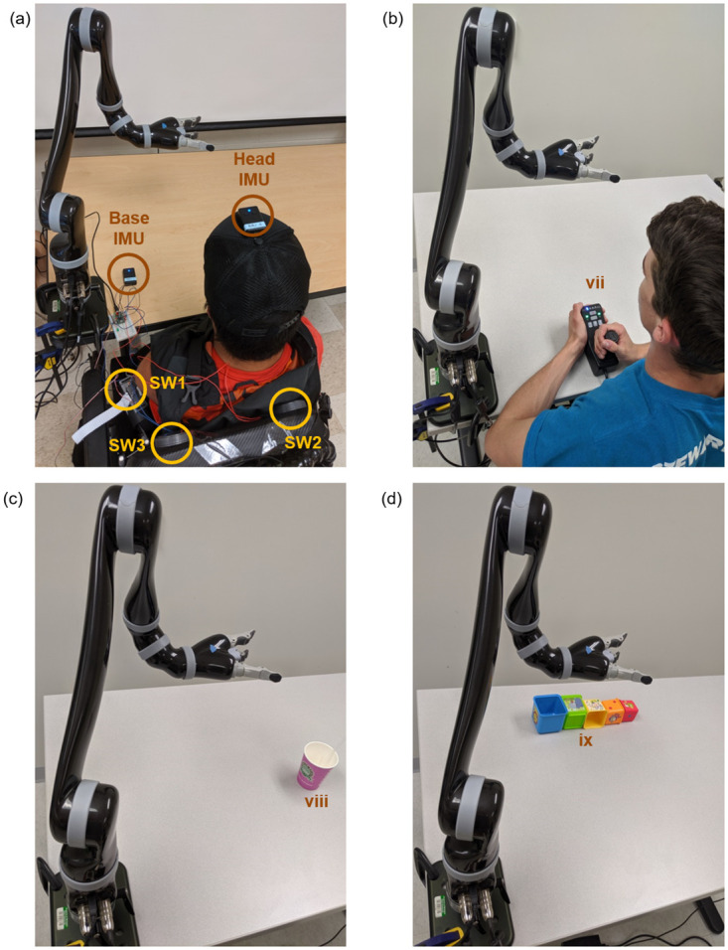

Figure 1: Photographs showing how non-invasive remote control work [6]

Invasive brain interfaces are also proposed to tackle the aforementioned issues. Employing Brain-Computer Interfaces (BCI), microelectrodes are precisely placed within the brain to target specific neurons [9]. After installation of interfaces in Figure 2, they can last for a relatively longer time, at least two years [10]. The larger number of channels enabled the ability for users’ brains to transmit high-resolution data for controlling. Nevertheless, the implantation of these technologies may leave scars on brain tissues. Those scars impede the ability of electrodes to transmit signals as the numbers of damaged tissues increase, which further increase the risk of electrode induced injury [11]. The permanent brain damage of invasive interfaces has become a concern for the technologies.

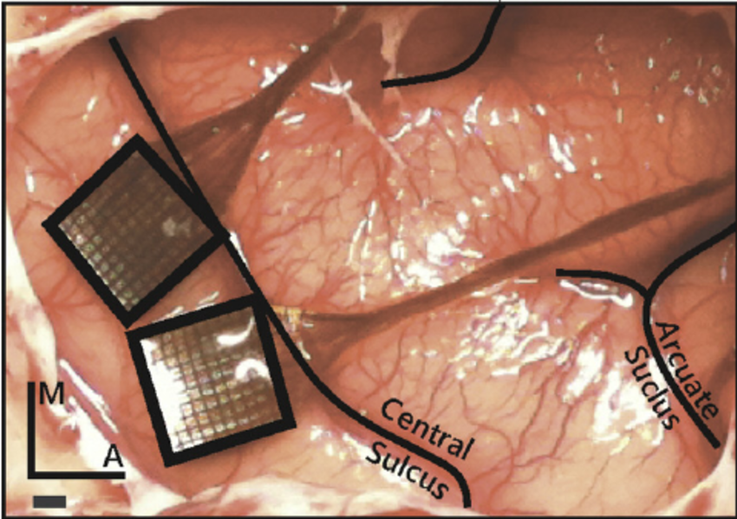

Figure 2. Illustration of invasive brain-computer interface (utah arrays) [9]

Although various technologies are developed, the challenge of maintaining an accurate signal transmission while preventing brain damage remains. Hence, Shape Memory Alloy (SMA) electrodes have significant advantages. Applying SMAs as probes for BCI, the probes can be inserted into the brain with minimal brain tissue damage [12]. The materials of SMAs are also highly bio-safe compared to other existing probes [13]. Therefore, these innovations have the advantages of both non-invasive and invasive controls. Moreover, our innovations are able to achieve single neuron detections at a higher speed and precision. The computer can form a more precise mapping of neural activity and avoid noise affect signal detection. As a result, an assiduous control over artificial devices [14]. While it requires further efforts to reduce the cost of probes, its accuracy and non-invasive features make it stand out in the field.

In summary, while remote controls and invasive brain control excel in specific areas, they are limited by factors like signal processing or brain tissue damage. Albeit the high manufacturing cost of SMAs, minimising brain damage while performing high-accuracy control emerge as most reliable and promising.Hence, it is believed further research of SMAs can overcome the challenges of risks in the field of Brain-Computer Interface and offers an alternative to BCI probes.

# 

# 

# 

# 

# 

# 

# 

# **Working principles**

Shape Memory Alloys (SMA) Probes is an alternative to the traditional probes used in Brain-Computer Interface. These materials differ from normal probes as they have the ability to return to their original shape under certain temperatures [15]. The system consists of two parts, silicon base for conducting electrical signals and SMA Probes for extracting data from neurons. Compared to traditional probes, it can achieve single neuron detection and process signals from a single neuron directly [14],[16]. Besides, it is non-invasive compared to invasive microelectrodes. Hence, SMAs can acquire a high resolution of signal transmission while not leaving scars or damages in human brains.

Initially, the patient will undergo a minimal invasive surgery [17] to insert the silicon base and SMA probes. The one micrometre probes are usually made with Nickel-Titanium (Ni-Ti) [18]. Due to its high strength, resistance and superelasticity [19]-[22], it can return to a predetermined shape after passing a threshold temperature. In summary, the probes turn straight below the limit and turn into spiral shape after exceeding the limit. These technologies take advantage of these properties, which enables the probes to be installed in a compact form [16],[23], minimising the damage to human tissues during surgery. In Figure 3, it is observed that the probes turn significantly after passing a threshold temperature [24]. Since the temperature of the brain (around 40℃) [25] is higher than the room temperature (around 25℃), the probes are gradually heated up to an extent higher than the threshold temperature. Subsequently, the probes will automatically change to a spiral shape and grab around a single neuron, showcased in Figure 4. Instead of inserting probes straight into brain tissues, the SMAs take a less intrusive approach. After installation of the probes, the temperature is controlled at a range of body temperature to prevent damage of brain tissues [26].

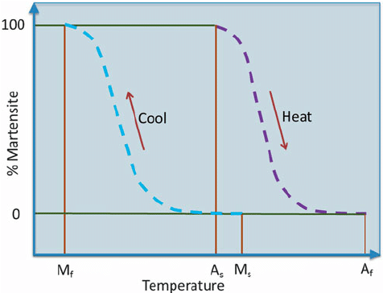

Figure 3, Effects of temperature on SMAs (Ni-Ti-Pd type) [24]

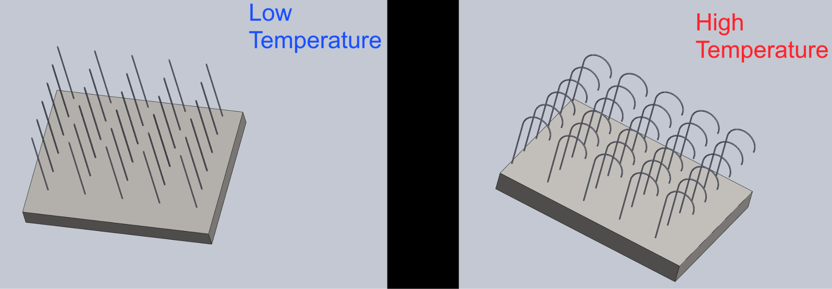

Figure 4. Shape of SMAs before and after heating

Monitoring of SMA probes is required to keep the operation safe. Two-way temperature sensors are installed to send real time data of temperature to the computer [27]. Hence, the temperature can be controlled when unexpected conditions, like fever, occur. The sensors acknowledge the temperature environment if the probes exceed threshold temperature [28], which may lead to undesirable bending in the brain, damaging brain tissues. In conclusion, SMAs are installed accurately and safely by the aforementioned measures.

After the probes and neurons are well connected, the electrode can transmit electrical signals to the devices outside via BCI. The silicon base has a high electrical conductivity [29], allowing the signal to be transmitted efficiently. Those signals are processed by the BCI system to control the artificial arms or legs. By the BCI translation algorithm, those signals sent by SMAs are translated in machine language, giving real-time commands to the prosthetics.

# 

# 

# 

# 

# 

# 

# 

# 

# 

# 

# **Feasibility and Benefits**

To implement SMAs into BCIs, different perspectives of feasibility needed to be evaluated to ensure the feasibility. The aspects can be divided into economic, social and technological.

Economically, the material used, Nickel-Titanium probes are exorbitant [30]. Compared to other materials used in the probes [30],[31], like stainless steel or cobalt-chromium, Ni-Ti is pricier than those common metals. However, Ni-Ti probes have unique properties such as shape memory effect [22], biosafety [33] and high corrosion resistance [34]. Alongside, the amount of Ni-Ti in the SMAs are small because the chips are manufactured in a microscopic scale. The long-term stability of Ni-Ti [35] also lengthen the lifespan of the probes. In the long term, the additional cost of Ni-Ti used is compensated by less replacement of probes, which also lower the risks of damage to the brain during surgery.

Socially, the SMAs are more welcomed by people due to its non-invasive prosperity [36]. After recovery of surgery, the individuals can control their artificial external devices without obvious and heavy tools. The individuals are able to enjoy a better quality of life and integrate into the society. SMAs surgery also have minimal effect on their appearance [37], aligning to the society of inclusivity.

Technically, the long-term sustainability of SMAs inside the brain are yet to be researched. Despite the fact that SMAs are highly resistant to corrosion [38] and withstanding repetitive mechanical movement of bending, the long run is yet to be confirmed. The Ni-Ti alloy will go through a process of degradation inside the body [39]. Such a process might lead to damage of brain tissues, lowering the credibility and reliability of alloys. The aforementioned issue prohibits a long term, stable usage of SMAs in the brain.

# **Conclusion**

The primary goal of the innovation is improving the accuracy of artificial limbs by using SMAs in neuron signals detecting. The disabled individuals who rely on artificial arms or legs have struggled with the limitations of conventional controlling devices [40]. The limitations hinder them from integrating into society [41]. This innovation enables the user to control their arms or legs with their brain by connecting brain neurons to SMA probes, while ensuring reliable, effective and accurate neuron signal transmission. Establishing such connections allows users to regain their function of extremities while not damaging brain tissues. However, the arm might not be affordable for everybody as the cost of the innovation is relatively high [32], Therefore, further research on reducing the manufacturing cost is required. Affordable materials to replace Ni-Ti can be researched.

# 

# **References**

[1]

S. Calvert, “Challenges for People with Disabilities,” *Ballard Brief*, vol. 2021, no. 3, Sep. 2021, Available: https://scholarsarchive.byu.edu/ballardbrief/vol2021/iss3/6/

[2]

M. A. Sayed, N. Jahan Prithee, and H. U. Zaman, “Robotic Helping Hand: A New Mechanism for Helping Disabled People,” *IEEE Xplore*, Feb. 01, 2020. https://ieeexplore.ieee.org/document/9112576 (accessed Jul. 15, 2023).

[3]

G. Nantzios, N. Baras, and M. Dasygenis, “Design and Implementation of a Robotic Arm Assistant with Voice Interaction Using Machine Vision,” *Automation*, vol. 2, no. 4, pp. 238–251, Oct. 2021, doi: https://doi.org/10.3390/automation2040015.

[4]

C. Sayers, *Remote Control Robotics*. New York: Springer-Verlag, 1999.

[5]

Kais Belwafi and F. Ghaffari, “Thought-Controlled Computer Applications: A Brain–Computer Interface System for Severe Disability Support,” *Sensors*, vol. 24, no. 20, pp. 6759–6759, Oct. 2024, doi: https://doi.org/10.3390/s24206759.

[6]

S. Aspelund, P. Patel, M.-H. Lee, F. A. Kagerer, R. Ranganathan, and R. Mukherjee, “Controlling a robotic arm for functional tasks using a wireless head-joystick: A case study of a child with congenital absence of upper and lower limbs,” *PLOS ONE*, vol. 15, no. 8, p. e0226052, Aug. 2020, doi: https://doi.org/10.1371/journal.pone.0226052.

[7]

M. Ghovanloo, “Chapter 22 - Wearable and non-invasive assistive technologies,” *ScienceDirect*, Jan. 01, 2021. https://www.sciencedirect.com/science/article/pii/B978012819246700022X

[8]

Anke Fischer-Janzen, T. M. Wendt, and Kristof Van Laerhoven, “A scoping review of gaze and eye tracking-based control methods for assistive robotic arms,” *Frontiers in Robotics and AI*, vol. 11, no. 0, Feb. 2024, doi: https://doi.org/10.3389/frobt.2024.1326670.

[9]

A. T. Rajan *et al.*, “The effects of chronic intracortical microstimulation on neural tissue and fine motor behavior,” *Journal of Neural Engineering*, vol. 12, no. 6, p. 066018, Oct. 2015, doi: https://doi.org/10.1088/1741-2560/12/6/066018.

[10]

C. Sponheim *et al.*, “Longevity and reliability of chronic unit recordings using the Utah, intracortical multi-electrode arrays,” *Journal of neural engineering*, vol. 18, no. 1, Art. no. 6, 2021.

[11]

P. R. Patel *et al.*, “Utah array characterization and histological analysis of a multi-year implant in non-human primate motor and sensory cortices,” *Journal of neural engineering*, vol. 20, no. 1, Art. no. 1, 2023.

[12]

L. Petrini and F. Migliavacca, “Biomedical Applications of Shape Memory Alloys,” *Journal of Metallurgy*, vol. 2011, pp. 1–15, 2011, doi: https://doi.org/10.1155/2011/501483.

[13]

M. Es-Souni, M. Es-Souni, and H. Fischer-Brandies, “Assessing the biocompatibility of NiTi shape memory alloys used for medical applications,” *Analytical and Bioanalytical Chemistry*, vol. 381, no. 3, pp. 557–567, Jan. 2005, doi: https://doi.org/10.1007/s00216-004-2888-3.

[14]

V. Salari, S. Rodrigues, E. Saglamyurek, C. Simon, and D. Oblak, “Are Brain–Computer Interfaces Feasible With Integrated Photonic Chips?,” *Frontiers in Neuroscience*, vol. 15, Jan. 2022, doi: https://doi.org/10.3389/fnins.2021.780344.

[15]

J. Uchil, “Shape memory alloys — characterization techniques,” *Pramana*, vol. 58, no. 5–6, pp. 1131–1139, May 2002, doi: https://doi.org/10.1007/s12043-002-0229-7.

[16]

F. Mo *et al.*, “Single-Neuron Detection of Place Cells Remapping in Short-Term Memory Using Motion Microelectrode Arrays,” *SSRN Electronic Journal*, vol. 1, no. 1, Jan. 2022, doi: https://doi.org/10.2139/ssrn.4162292.

[17]

A. Zajdel, A. Wilczok, K. Jelonek, A. Kaps, M. Musiał‐Kulik, and J. Kasperczyk, “Cytotoxic effect of targeted biodegradable epothilone B and rapamycin co‐loaded nanocarriers on breast cancer cells,” *Journal of Biomedical Materials Research Part A*, vol. 109, no. 9, pp. 1693–1700, Mar. 2021, doi: https://doi.org/10.1002/jbm.a.37164.

[18]

N. Sharma, T. Raj, and K. Jangra, “Applications of nickel-titanium alloy,” *Journal of Engineering and Technology*, vol. 5, Art. no. 1, 2015.

[19]

Minja Miličić Lazić *et al.*, “A brief overview and application of nickel-titanium shape memory alloy in dentistry,” Petrica Vizureanu and Madalina Simona Baltatu, Eds., IntechOpen, 2024. doi: https://doi.org/10.5772/intechopen.1004825.

[20]

“NICKEL-TITANIUM SHAPE MEMORY ALLOYS - CSIR - NAL,” *Nal.res.in*, 2017. https://www.nal.res.in/en/technology/nickel-titanium-shape-memory-alloys

[21]

C. Naresh, P. Bose, and C. Rao, “Shape memory alloys: a state of art review,” in *IOP Publishing*, 2016, p. 012054.

[22]

T. W. Duerig, *Engineering aspects of shape memory alloys*. London: Butterworth-Heinemann, 1990, pp. 21–25.

[23]

H. Wu *et al.*, “Current status and challenges of shape memory scaffolds in biomedical applications,” *MedComm – Biomaterials and Applications*, vol. 3, no. 3, Sep. 2024, doi: https://doi.org/10.1002/mba2.95.

[24]

“Precipitation Strengthened Ni-Ti-Pd Shape Memory Alloys | T2 Portal,” *Nasa.gov*, 2024. https://technology.nasa.gov/patent/LEW-TOPS-174

[25]

N. M. Rzechorzek *et al.*, “A daily temperature rhythm in the human brain predicts survival after brain injury,” *Brain*, vol. 145, no. 6, pp. 2031–2048, Jun. 2022, doi: https://doi.org/10.1093/brain/awab466.

[26]

P. M. Navarro, Dorin Copaci, J. Arias, and D. B. Rojas, “Design of an SMA-Based Actuator for Replicating Normal Gait Patterns in Pediatric Patients with Cerebral Palsy,” *Biomimetics*, vol. 9, no. 7, pp. 376–376, Jun. 2024, doi: https://doi.org/10.3390/biomimetics9070376.

[27]

W. Wang, W. Zeng, Ruan Weitong, M. Eric, and Sameer Sonkusale, “Thermo-Mechanically Trained Shape Memory Alloy for Temperature Recording With Visual Readout,” *IEEE sensors letters*, vol. 5, no. 1, pp. 1–4, Jan. 2021, doi: https://doi.org/10.1109/lsens.2020.3044294.

[28]

M. H. Moghadam, M. R. Zakerzadeh, and M. Ayati, “Robust sliding mode position control of a fast response SMA-actuated rotary actuator using temperature and strain feedback,” *Sensors and Actuators A: Physical*, vol. 292, pp. 158–168, Jun. 2019, doi: https://doi.org/10.1016/j.sna.2019.01.002.

[29]

J. Srivastava, M. Prasad, and J. Wagner, “Electrical conductivity of silicon dioxide thermally grown on silicon,” *Journal of The Electrochemical Society*, vol. 132, Art. no. 4, 1985.

[30]

H.-W. Liu, D. Paul Bishop, and K. P. Plucknett, “A comparison of Ti–Ni and Ti-Sn binary alloys processed using powder metallurgy,” *Materials Science and Engineering: A*, vol. 644, pp. 392–404, Jul. 2015, doi: https://doi.org/10.1016/j.msea.2015.07.085.

[31]

P. S. Nayab and Mohd. Shkir, “Rapid and simultaneous detection of Cr (III) and Fe (III) ions by a new naked eye and fluorescent probe and its application in real samples,” *Sensors and Actuators B: Chemical*, vol. 251, pp. 951–957, Nov. 2017, doi: https://doi.org/10.1016/j.snb.2017.05.102.

[32]

A. T. Aron, K. M. Ramos-Torres, J. A. Cotruvo, and C. J. Chang, “Recognition- and Reactivity-Based Fluorescent Probes for Studying Transition Metal Signaling in Living Systems,” *Accounts of Chemical Research*, vol. 48, no. 8, pp. 2434–2442, Jul. 2015, doi: https://doi.org/10.1021/acs.accounts.5b00221.

[33]

Y. Okazaki and S. Katsuda, “Biological Safety Evaluation and Surface Modification of Biocompatible Ti–15Zr–4Nb Alloy,” *Materials*, vol. 14, no. 4, p. 731, Feb. 2021, doi: https://doi.org/10.3390/ma14040731.

[34]

B. Liu *et al.*, “Safety Evaluation for Nickel Release of Nickel–Titanium alloys Cardiovascular stents,” *Research Square (Research Square)*, Mar. 2024, doi: https://doi.org/10.21203/rs.3.rs-4057011/v1.

[35]

D. S. Belov *et al.*, “Thermal stability and chemical resistance of (Ti,Al)N-Cu and (Ti,Al)N-Ni metal-ceramic nanostructured coatings,” *Applied Surface Science*, vol. 388, pp. 2–12, Dec. 2016, doi: https://doi.org/10.1016/j.apsusc.2016.06.106.

[36]

M. Meglio, “Minimally Invasive Brain Surgery for Drug-Resistant Epilepsy Preferred Over Invasive Craniotomy, Medication Use,” *Neurology live*, Mar. 28, 2022. https://www.neurologylive.com/view/minimally-invasive-brain-surgery-drug-resistant-epilepsy-preferred-over-invasive-craniotomy-medication (accessed Nov. 09, 2024).

[37]

J. Peksa and D. Mamchur, “State-of-the-Art on Brain-Computer Interface Technology,” *Sensors*, vol. 23, no. 13, p. 6001, Jan. 2023, doi: https://doi.org/10.3390/s23136001.

[38]

S. Sampath, Harris, and T. S. Srivatsan, “Environment-Induced Degradation of Shape Memory Alloys: Role of Alloying and Nature of Environment,” *Materials*, vol. 16, no. 16, pp. 5660–5660, Aug. 2023, doi: https://doi.org/10.3390/ma16165660.

[39]

M. Kaczmarek, W. Simka, A. Baron, J. Szewczenko, and J. Marciniak, “Electrochemical behavior of Ni-Ti alloy after surface modification,” *Journal of Achievements in Materials and Manufacturing Engineering*, vol. 18, Art. no. 1-2, 2006.

[40]

L. Petrich, J. Jin, M. Dehghan, and M. Jagersand, “Assistive arm and hand manipulation: How does current research intersect with actual healthcare needs?,” *arXiv.org*, 2021. https://arxiv.org/abs/2101.02750 (accessed Nov. 10, 2024).

[41]

B. J. Lutz and B. J. Bowers, “Disability in Everyday Life,” *Qualitative Health Research*, vol. 15, no. 8, pp. 1037–1054, Oct. 2005, doi: https://doi.org/10.1177/1049732305278631.